

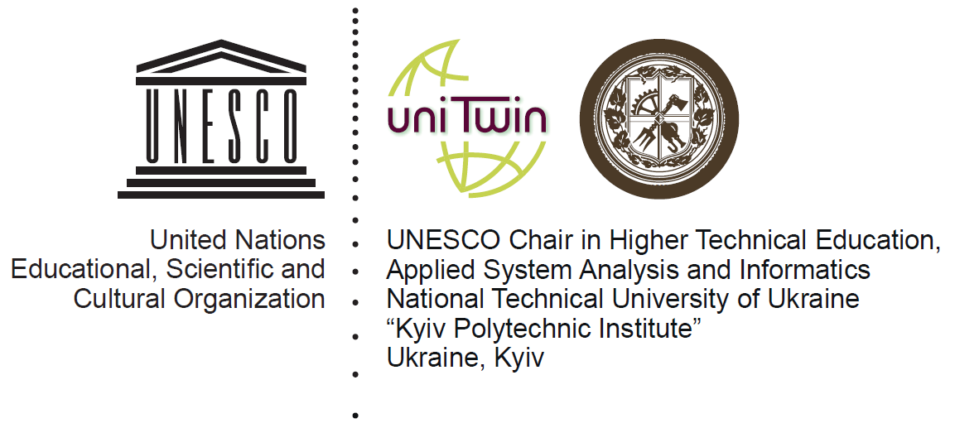

UNIDO-GEF Project Improving energy efficiency and promoting renewable energy in the agro-food and other small and medium enterprises (SMEs) in Ukraine




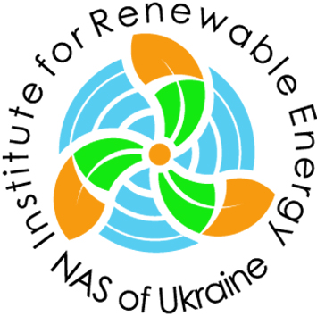
NTUU "KPI" (37 Peremohy ave., Kyiv)

XVIIth INTERNATIONAL SCIENTIFIC AND PRACTICAL CONFERENCE
RENEWABLE ENERGY AND ENERGY EFFICIENCY of the XXI CENTURY
September, 29th – 30th, 2016

REGISTRATION FORM

Name: _______________________________________________________________________________
Position: _____________________________________________________________________________
Academic degree: ______________________________________________________________________
Organization: _________________________________________________________________________
_____________________________________________________________________________________
Mailing address: _______________________________________________________________________
_____________________________________________________________________________________
Phone.: ____________________________________
Fax: _______________________________________
Е-mail: _____________________________________

Report title: ___________________________________________________________________________
_____________________________________________________________________________________
_____________________________________________________________________________________

Please book hotel rooms for _____ people from _____.09.2016 till _____.09.2016
Date ________________ Signature ___________________
*Registration form should be sent back:
by e-mail: info@ive.org.ua or
by fax: +38 (044) 206-28-09

Should any questions arise don’t hesitate to contact organizing committee:
Phone/fax: +38 (044) 206-28-09
e-mail: info@ive.org.ua

